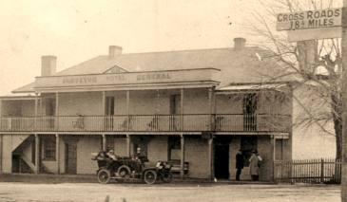
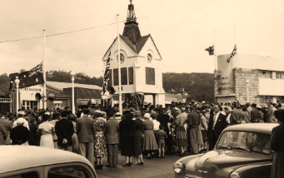
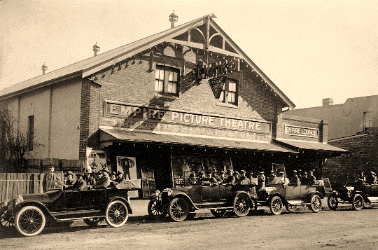
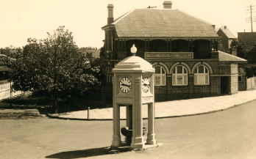

BERRIMA DISTRICT

HISTORICAL & FAMILY

HISTORY SOCIETY Inc.

Founded 1960
Located in the Wingecarribee Shire,
Southern Highlands of NSW
ABN 29 362 616 937

Mittagong

Berrima

Bowral

NEWSLETTER

No 535 March 2021

Moss Vale

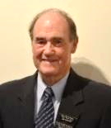
From the President’s Desk
Welcome to our March edition of the Society’s newsletter as we emerge from the COVID lock-down.
With the vaccines now being rolled out across Australia, we begin to see signs of life returning to the local fields of art and entertainment with the recent visit to the Berrima Museum of representatives from Create NSW and the Southern Tablelands Arts. (Refer to story on page 3).
Create NSW is well known for its promotion of the arts, screen and culture in an integrated entity and is responsible for furthering the Government’s vision for NSW. Create NSW invests in the success and future of arts, screen and culture in NSW through infrastructure and funding programs.
Our society is very familiar with the Create NSW program as they provided half the funding for the recently completed digital gallery and renovations at the Berrima Museum.
Southern Highlands Arts is possibly less known in our district as they are located in Goulburn. They are now more actively promoting this region including a short video of the Museum on their website.
One aspect of renewed activity in this field highlights the lack of volunteers, especially younger ones standing up to eventually replace the ever-ageing band of dedicated volunteers.
ALL GENERAL MONTHLY MEETINGS POSTPONED TILL FURTHER NOTICE

The Family History Group will meet each month on the first Wednesday at 1pm.

It is hoped that with renewed activities taking place this year people might once again venture out of their comfort zone and join the enthusiastic band of current volunteers.
Another statistic across our ageing demographic is a slowly declining number of financial members in our Society. Our membership income, together with the takings from the Berrima Museum, are the major source of funding for our Society. It is hoped that with a gradual return to normal this year our membership numbers will begin to rise again.
The Archives research team is continuing to attend to an interesting array of research enquiries from both members and the general public. Visitors are regularly accessing our collection of newspapers post the 1950s which are not yet digitised on Trove. In Conservation a new single bay of steel shelving has been installed to accommodate current and future issues of the Southern Highlands News.
The Family History group held a very successful meeting in February with an enthusiastic discussion regarding a program of topics for future meetings.
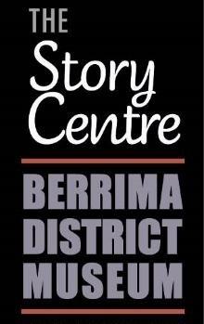
Their next meeting will be held on Wednesday
3 March at 1.00pm when Denise Power will give a short presentation on her NSW BDM experiences.
Ian Mackey

Moore Memorable Musings
BOOKCLUBS
What do I miss? Second-hand bookshops where I can find things I had no idea I wanted. - David Mitchell
I recently read a book on How to Sketch, but found it a little too drawn out. - Bruce Moore
Never lend books, for no one ever returns them; the only books I have in my library are books that other folks have lent me. - Anatole France
A good novel tells us the truth about its hero; but a bad novel tells us the truth about its author. - Gilbert K. Chesterton
A bookstore is one of the only pieces of evidence we have that people are still thinking. - Jerry Seinfeld
Our bookclub doesn’t require you to read a book, only a wine label. - Bruce Moore
Mum keeps asking me why I sit in the wardrobe reading a book. I replied “that’s Narnia business.”
Asking the librarian does she have a book on Pantomimes. She said “it’s behind you!”
There’s a very interesting book on anti-gravity. I couldn’t put it down!
I asked the local library for a book on fixing automatic car gearboxes. They only have manuals.
A man actually swallowed a dictionary. Afterwards he had Thesaurus throat.
Some bookclubs have abridged versions for busy people. There is a Pamphlet Club in Sydney for tired and over-worked Mums. - Kathy Lette
When the white missionaries came to Africa, they had the Bible and we had the land. They said 'Let us pray.' We closed our eyes. When we opened them, we had the Bible and they had the land. - Desmond Tutu
A blonde girl strides into a library and asks the librarian ‘I’d like large fries, one cheeseburger and a hash brown”.
‘This is a library’, replies the librarian softly but sternly. The blonde looks around at the quiet customers sitting and reading.
‘Sorry,’ she whispers ‘I’d like large fries, one cheeseburger and a hash brown.’
Bruce Moore
Berrima District Museum
THE STORY CENTRE
1a Market Place cnr Bryan St, Berrima 2577
OPEN WEDNESDAY TO SUNDAY
10.00am to 4.00pm throughout the year. This includes during school and public holiday periods. Closed Christmas Day and New Year’s Day.
Groups welcome at other times by arrangement. Ph John 4854 0165.
Museum: Phone 4877 1130 or
email bdmuseum@bigpond.com
Managed and operated by members of our Society who volunteer their time and expertise.
Archives’ opening hours
Monday 10:00 am – 4:00 pm
Tuesday 10:00 am – 4:00 pm
Saturday 10:00 am – 1:00 pm
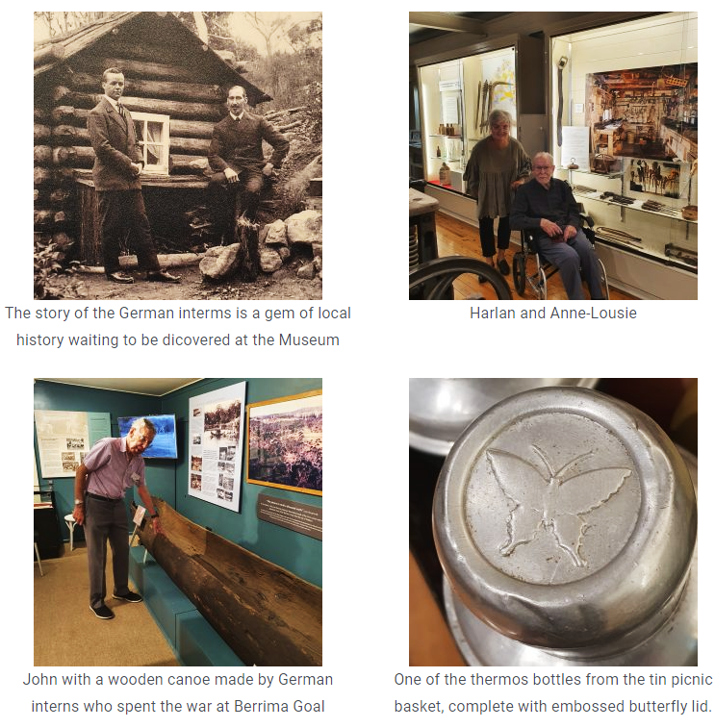
Above is a screen capture from the Southern Tablelands Arts website
showing images of our museum and exhibits as part of their feature story on Berrima District Museum. See next page for more about this initiative.
Membership Details
Please note that all membership enquiries and changes of address details should be addressed to:
The Membership Secretary
c/- the Society’s postal address
or email: bdhsarchives@gmail.com
Arrangements re pandemic
PLEASE NOTE:
While our Archives/Research Centre at Mittagong is once again open to the public, those wishing to visit are asked to make contact beforehand so their attendance can be scheduled, thus allowing us to keep numbers within the current prescribed limits. Visitors must sign in on entry.
Visitors to the Museum at Berrima are required to sign in and out, and to observe social distancing. Our staff are dedicated to maintaining hygiene and well-being measures.

Museum open and attracting interest
In early February Southern Tablelands Arts visited our Berrima District Museum to coincide with a visit from Anne-Louise Rentell of Create NSW. Create NSW is the NSW Government's arts policy and funding body which supports the Regional Arts Organisations and provides advice to the Minister for the Arts.
Southern Tablelands Arts is one of 14 Regional Arts Development Organisations in NSW, which undertake the programming and planning that meets the needs of each region and maintain relationships with local councils and shires, local arts councils, arts and cultural groups, arts organisations, indigenous groups and institutions and other regional service deliverers. Its contributing Councils are: Goulburn Mulwaree, Hilltops, Upper Lachlan Shire, Wingecarribee Shire, Wollondilly Shire and Yass Valley.
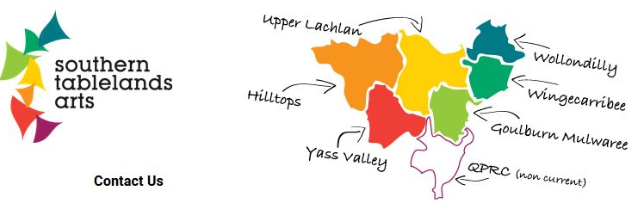

Southern Tablelands Arts maintains an attractive website, www.southerntablelandsarts.com.au, and issues a weekly e-newsletter to subscribers which highlights current events and activities in its region.
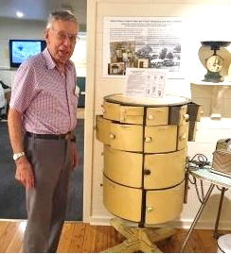
During the visit John Schweers and Harlan Hall shared their favourite object in the Museum’s current display, being the impressive Hurdy Gurdy rotating metal kitchen pantry, that would have been considered a luxury item in its day.
Lyn Hall’s favourite is a painted picnic basket made from an old kerosene tin. The tin was found inside a saddler’s shed, complete with tools and equipment that had long been locked up like a time capsule.
Short videos of John and Lyn displaying the objects are featured on the Southern Tablelands Arts website (viewable in Stories from the studio) along with a selection of photos showcasing the museum’s exhibitions and with this glowing description:
“Located in the delightful historic village of Berrima, this exceptional museum brings to life the history of the district. The museum features an amazing digital gallery currently showing Rembrandt in HD.”
“The Berrima District Museum is perfect for all ages and is engaging a whole new audience of locals and visitors alike with its fascinating mix of state-of-the-art digital storytelling, breath-taking photography, historical treasures, and passionate volunteers who bring local stories to life.”
It is also noted on the website that many of its areas attract tourists and visitors from Sydney and Canberra. Sport, fishing, arts, history, heritage and environment contribute to the rural experiences for visitors. The towns and villages are attractive for their history and heritage values and architecture including Thirlmere and The Oaks, Berrima, Bundanoon and Robertson, Marulan and Tarrago, Taralga, Laggan, Gunning and Collector. The whole area is known for cool climate wines with numerous arts, food and wine festivals a feature. There are a significant number of volunteer-run museums and historical societies, a number having a focus on a particular theme such as war, rail, building heritage and hospitals. Others are collectors of all things curious with a history within that location.
Our Society is grateful to the Arts team for shining a spotlight on the Museum which, since re-opening late last year, is now operating in a COVID-safe mode and generating much-needed income from a steady influx of visitors. The upgrading of the entrance foyer, exhibition rooms and with new display cases provided, has given visitors a more open, spacious and comfortable viewing experience.
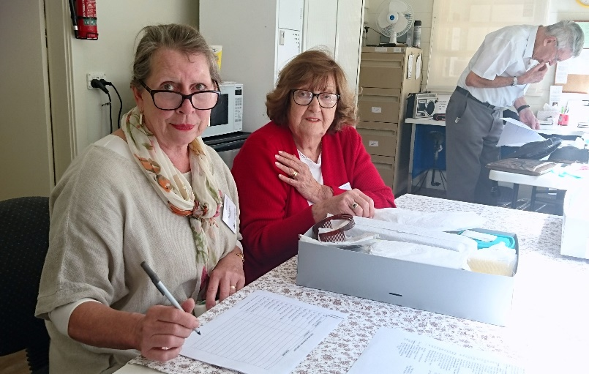
The recently renovated kitchen/office area is now more user-friendly for volunteers, as seen here with Maria French and Barbara Favretto examining donated items in the museum’s collection to assess their condition and usefulness. Museum manager John Schweers is thankfully now back at the helm.
The de Mestre family and Garryowen story
by Ian Mackey
A history of the de Mestre family commenced in last month’s issue and continues here. It was noted that Etienne de Mestre and family moved to the Southern Highlands in the late 1890s and, from 1913, lived at Garryowen, a substantial residence in Elizabeth St, Moss Vale. From 1934 to 1943 this residence would serve as a maternity hospital.
The de Mestre story so far: Etienne’s father, Prosper de Mestre, was born in France in 1789 and spent his childhood in the Caribbean and then in America, moving there with his mother. He arrived in Sydney in 1818 and earned success as an importer and merchant. He married colonial-born Mary Ann Black in 1821 and they had 10 children.
Prosper received a land grant in the Shoalhaven area in 1824 and this property became known as Terara. The family moved there around 1840, where Prosper died in 1844. Mary Ann lived for another 17 years – at Terara she raised her large family and created a productive farmstead with cattle and crops.
The interest of sixth child, Etienne Livingstone, born in 1832, was in horses. In the 1850s he set up a horse stud, stables and race track at Terara and earned a reputation as an exceptional trainer. Amongst the first horses he trained was Veno that belonged to George Taylor Rowe who owned a property at Lower Mittagong. Etienne won the first two Melbourne Cups (1861, 1862) with the horse Archer.
His story continues here. Etienne planned to enter Archer in the Melbourne Cup of 1863 but the Victorian Racing Club scratched him because his telegraphed acceptance arrived late. He said that he would never race again in Victoria, and other owners scratched their horses in sympathy. Eventually Etienne relented and in 1867 he took Tim Whiffler to Melbourne and won the Cup.
Etienne had an unbeaten record of three wins from three starts. He trained two other Melbourne Cup winners, Chester in 1877 and Calamia in 1878. His record of five wins stood for almost a century until Bart Cummings equalled the figure in 1975. Archer continued racing, and winning, despite the burden imposed by handicappers. His career ended in 1865 following a fall at training. He was retired to stud at Terara. When Archer died the body was taken to Braidwood and buried at Exeter farm.
Etienne de Mestre continued his successful training and breeding profession and, at the age of 41, married Clara Eliza Rowe at St. Matthias’s Church, Paddington on 27 December 1873. Clara was the daughter of George Taylor Rowe and Phoebe (nee Melville) and was born in 1852, one of ten children.
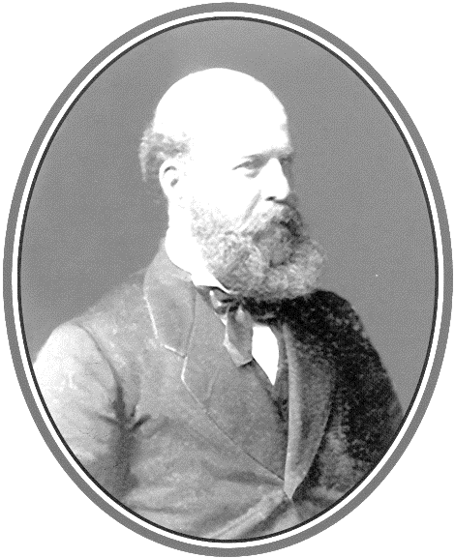
Etienne continued with his stud farm at Terara. In 1877 Victorian owner
C B Fisher retired from racing and all his stock was sold. De Mestre gambled heavily when he paid prices far beyond current values to purchase the best horses from Fisher.
In their first winter at Terara many of the brood mares died and few of the thoroughbreds lived up to their promise. De Mestre had also invested in several large Queensland stations and these were in trouble due to a devastating drought.
To add to his troubles de Mestre’s health failed and the doctors gave him little hope. However the trainer recovered and made a last-ditch effort to recover from his financial crisis.
He placed the largest single bet ever written in Australia to that date, £250 on a double for Navigator to win the VRC Derby and Gudarz to win the 1882 Melbourne Cup. Navigator won the first leg, but Gudarz could only manage third in the cup, and so went de Mestre’s chance of winning £50,000.
Etienne had some more minor wins, but on 23 April 1883, the auctioneer moved in on Terara. Bidding was brisk and the prices high, but they brought no benefit to de Mestre. All proceeds went to his mortgagees.
In his adversity, de Mestre was not friendless. A complimentary race meeting was held for his benefit at Randwick and with the proceeds he was able to retire to the Southern Highlands and start a new chapter in his life.
Clara was delighted with the move as she was born at Rowe’s Hill near Mittagong and christened at Christ Church, Bong Bong. She also believed that the change of air and lifestyle would be beneficial to Etienne.
The move came early in 1892 after de Mestre leased a property on Kangaloon Road on the outskirts of Bowral. The name of the property was Old Maryvale.
It did not take the family long to adjust to life in Bowral, although a tragic event occurred in 1893 when Clara gave birth to a son and the child died.
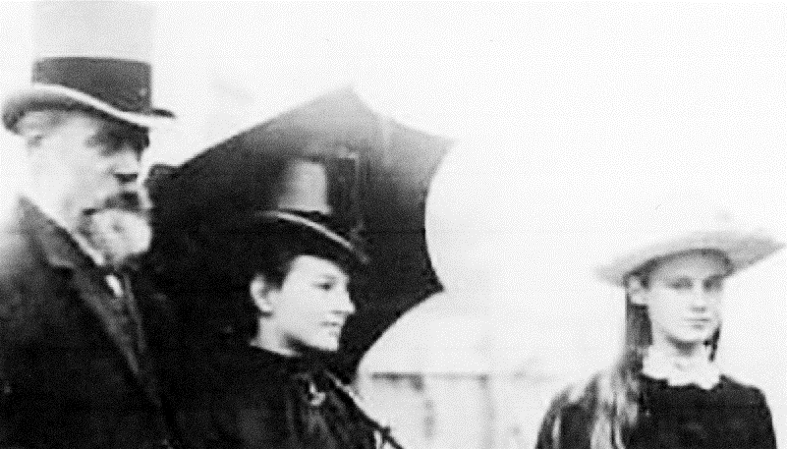
Etienne & Clara de Mestre with Helen, their first daughter; photo from the late 1880s
On 27 March 1894, Clara gave birth to her 10th child. The child, christened LeRoi Livingstone de Mestre, in later years became a famous impressionist artist in Australia. In the 1930s he was based in London and changed his name to Roy de Maistre.
Etienne de Mestre’s love of horse racing had never diminished. With the help of his sons Etienne George, then 21 years old, John, 14, and Hurtle, 12, he set about constructing a training track on the property and preparing for the 10th annual races at the Bong Bong course in January 1894.
The Bowral Free Press announced on 22 February 1896 that a race meeting was to be held on the
de Mestre race course at Bowral on Easter Monday.
On 12 December 1896, Clara’s last child was born at Maryvale, her fifth daughter, Beryl Marjorie de Mestre. After five years at Maryvale the year of 1897 brought about another move to a property leased by Etienne called Ulster Park at Fitzroy Falls.
Ulster Park was an imposing three-storey house with sixteen rooms and a large kitchen at the rear, built in the 1880s by Irishman Peter Francis Hart. Ulster Park later became the home of Doug Cull, who was President of our Society from 1973 to 1979.
Etienne was granted a Government pension in 1901. The family remained at Ulster Park for about five years before moving to Mount Valdemar, a magnificent home overlooking the village of Sutton Forest. The land had been acquired in 1878 by Anton Tange, born in Odense, Denmark, and he named the house Mount Valdemar in honour of Valdemar the Great, King of Denmark from 1157 to 1182.
Without establishing the exact date, the de Mestre family relocated once again during 1907. The move was made to a two-storeyed twin gabled house owned by Lady Emily Innes called Clover Hill, just down the road from Mount Valdemar situated on what is now the Illawarra Highway at Sutton Forest.
Marie Annette, the third daughter, married Philip Badgery at All Saint’s Church Sutton Forest on 1 June 1911 with the reception held at Clover Hill.
The de Mestre family enjoyed a very happy social life in the Southern Highlands. Etienne continued his love of horse racing and regularly attended the Bong Bong picnic races, on occasions entering a horse or two.
The three youngest children Nellie, Roi and Beryl were more into cultural aspects of the time and entertained at concerts presented by Saint Joseph’s School at Moss Vale with Nellie playing the piano and Roi performing solo on the violin.
The final move for Etienne and Clara came in 1913 when they departed Clover Hill and took up residency at Garryowen (below) in Elizabeth Street, Moss Vale.
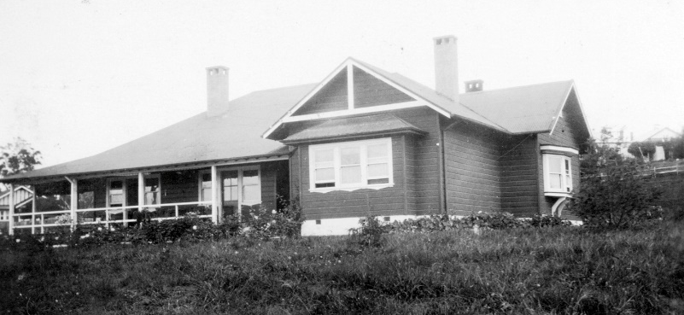
Three of the girls Alice, Nellie and Beryl were still living at home, and Roi, now nineteen, went to Sydney to study music and art at the State Conservatorium of Music and the Royal Art Society.
The eldest son Etienne Jnr had established himself as one of the leading trainers in England and the second son John had served in the Boer War and then joined the Westmoreland & Cumberland Yeomanry in England and was serving in Ireland.
Hurtle de Mestre, after also serving in the Boer War, was training horses in South Africa at Standerton near Johannesburg, and Edward was managing a station at Binalong.
During 1914 Nellie was married at Garryowen to Arthur MacMullen (Max) Yeates who managed the Yeates & Company’s commercial nursery at Exeter.
Etienne de Mestre lived quietly in his last few years at Garryowen. He was ill for three weeks before he passed away on 22 October 1916, aged 84 years. He was buried at Christ Church Cemetery, Bong Bong.
After his death Clara did not delay in bringing her ageing mother Phoebe to live with her and the girls at Moss Vale.
A highlight for the de Mestre women was the marriage of Alice to Frank Morrice at Garryowen on 10 October 1917. The reception was held at Garryowen.
Sadly, just ten days later on 20 October, Phoebe passed away, aged 92 years, and was buried next to Etienne in Christ Church cemetery, Bong Bong.
In 1918 Clara and Beryl were on the move again. Clara purchased a home called Hazelton on the south side of Moss Vale on the Sutton Forest Road.
Clara de Mestre passed away on 7 May 1934, aged
82 years. She was buried beside her husband and mother at Christ Church, Bong Bong.
Etienne and Clara’s happy times at Garryowen in their twilight years does not signify the end of this well-known property’s history as it later assumes a new identity as a maternity hospital … and that is another story.
Sources:
- Some factual information and the de Mestre family photographs are from: ‘The Master's Touch: Racing with Etienne de Mestre - Winner of Five Melbourne Cups’, by Keith W Paterson, Nowra (2008).
- The de Mestre biography file in the BDHS archives
Ulster Park on the Nowra & Fitzroy Falls Rd
The book “Echoes Through the Mist – a history of the Avoca District” was compiled in 1988 for the Avoca Bicentenary Committee. It was revised in 2013 by Ron Mumford and reprinted by our Society.
Included is a chapter by Doug Cull on Ulster Park, built at Yarrunga in 1881. Edited extracts follow here:
“All who have travelled the Moss Vale to Fitzroy Falls Road have seen Ulster Park, the old home on the hill about nine miles from Moss Vale. Every man, it has been written, builds his own monument and this imposing stone edifice on the roadside is that of Peter Hart. It was in the fifties of last century that Hart first set eyes upon the section of rising ground which reared above the level of the surrounding scrub. A young man, a carpenter and joiner, he came from the old country to seek his fortune, and fate found him plying his trade at Sutton Forest.
His path was a peculiarly rosy one in those days, for the gold rush had enticed many from their work and those who remained reaped a harvest. Peter was one of these and success found him engaging in business in Sydney, demolishing and re-building houses and terraces, but before long he submitted to a yearning to again return to the locality upon which his heart was bent. First, he negotiated the purchase of the land upon which Ulster Park now stands.
Yarrunga was then a cluster of houses at the 9-mile post, one of them being the post office. Here, Mrs Payne lived, and was ready with hot coffee for the mail driver when he drove his horses round the curve to the door at 11 o'clock at night on his way to Nowra. The coach on the return journey would arrive at 3am and the coffee would again be ready.
Near the post office stood Webb's saw-mill. Further back was Jimmy Jones's farm; across the road where stood the dilapidated “Rebecca Cottage” lived Mrs Ritchie, and later, Roger Spain, a bricklayer, who helped to build the big house. All these places were acquired eventually by Peter Hart, and the post office was moved along to past the 10-mile post.
Peter had the property fenced, cleared and cultivated by local labour, bought a piece of land with stone on it and had the stone quarried and cut for the building of his house. He erected a brick-kiln where the big dam stands near the road.
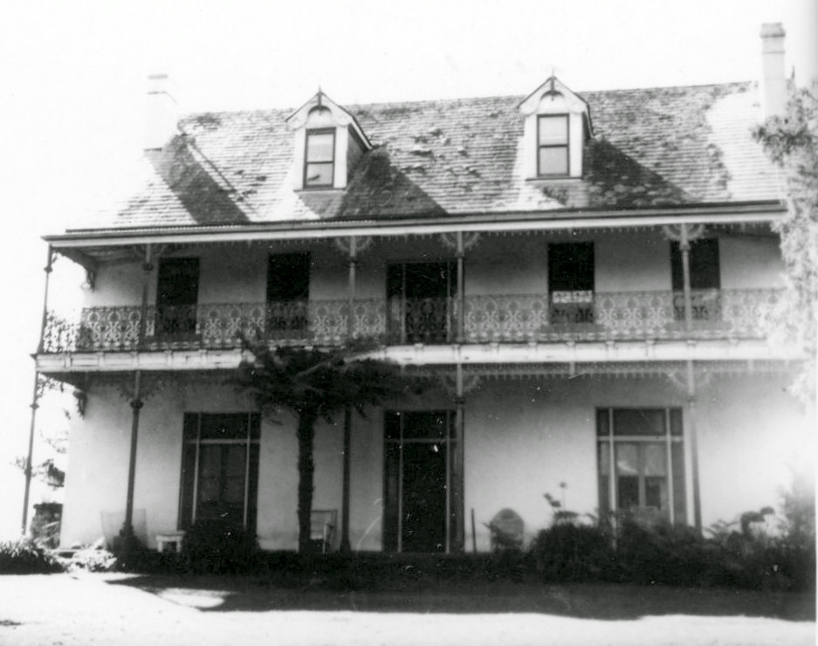
Then the house was built, solid and strong; 16 rooms in the three-storeyed main building, the only fault being the omission of a bathroom, which had to be added and clings like a limpet to the outside back wall. The rear part, a kitchen with a big open fireplace where log fires crackled and the kettle hung on a crane and with a baker's oven built into the wall; other bedrooms, a concrete-floored billiard room, the ballroom with its fireplace, and a cellar which Peter did not neglect to stock – were all well-built, and will stand for many a day.
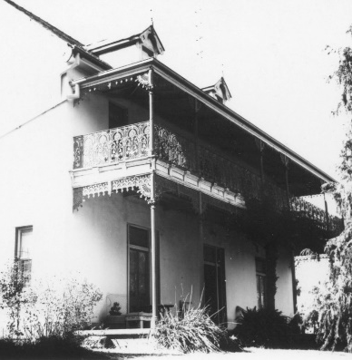
Peter Hart leased the property about 1896 to the de Mestres, who had it for several years, and after them the Wrights had it for a sheep-run. Later Wyatt rented it, and then Peter Hart returned.”
Tours of Ulster Park were held from the 1970s to raise funds for the BDHS, the then owner Doug Cull being our Society’s President for most of that decade.
The two sons of Etienne and Clara
de Mestre who served in the Boer War
“Forgotten Soldiers” was published by our Society in 2014. Updated and expanded by Janet Black, the book builds on work by the late Colin Sproule. It provides details about the men and women from the Southern Highlands who served in the Boer War, 1899 to 1902. Presented below are extracts from the two de Mestre entries in the book.
De Mestre, John Charles Prosper, No 187, Trooper, “B” Squadron. Born in 1879 to Etienne and Clara (nee Rowe) at Terrara, Shoalhaven.
When John enlisted, his attestation papers said he was single, working as a farmer and his next-of-kin was given as his father at Mt Valdemar, Sutton Forest. During his time in South Africa, according to family stories, John achieved some success as an amateur jockey.
After the war John moved to England and worked as a small-arms instructor at Hythe, Kent, later joining the Westmoreland Cumberland Yeomanry and saw service in Ireland during the 1915 Easter uprising. He was gazetted as 2nd Lieutenant in November 1915 and commissioned Captain in May 1918.
John married Mollie (Mary Isobel) Persse in 1915 and they had three children. In 1919 he was appointed custodian of the abbey ruins at Titchfield Abbey.
From 1922 he was a tenant dairy farmer at Newnham Grange, Northamptonshire until he was ruined after an outbreak of foot and mouth disease. Later he worked for the Greyhound Racing Association. Both John and his wife died in 1957 in Birmingham.
De Mestre, Hurtle Edwin, No 194, Trooper, “D” Squadron. Born in 1881 to Etienne and Clara (nee Rowe) at Terrara, Shoalhaven. He was the younger brother of John Charles (cited above).
Although Hurtle originally enlisted as a trooper he had already been promoted to corporal by the time the troops embarked for South Africa on 28 February 1900. After distinguishing himself at the battle of Rustenburg, Hurtle was promoted to sergeant on
26 March 1901 and to lieutenant on 8 May 1901.
At this time, he was transferred to the 2nd NSW Mounted Rifles and ended the war as a lieutenant and adjutant with the 3rd NSW Imperial Bushmen.
An item published in the Mittagong Express in September 1902 indicates some of Hurtle’s other (non-military) activities:
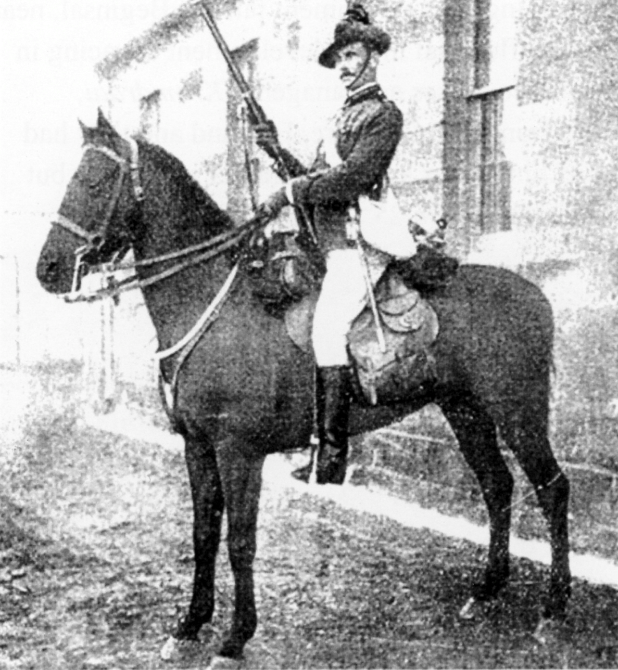
Hurtle de Mestre
(from Renshaw Family Tree, Ancestry.com.au)
“. . . of a gymkhana held . . . at Klerksdorp of the six events on the programme, five were won by Australian horses, while the winner was in every instance ridden by an Australian, Lieut. de Mestre (Moss Vale) piloting three to victory.”
Hurtle settled in South Africa after the Boer War, joining the Government farm at Beginsal, near Standerton, south-east of Johannesburg. He was influential in the development of racing in South Africa and in the breeding and training of race horses as manager of Kromdraai, Standerton.
In 1909 he married Daisy Newland of Herefordshire, England, and they had two children. He established himself as an owner/trainer in Durban at the end of World War I, but was unfortunately killed after being thrown from a horse in 1922.
The book is available from the Society for $20
In his address at the launch of the book in May 2014, Dr Craig Wilcox, a military historian based in Sydney, said how the book reminds us all that Australian military history does not start with WW I.
He complimented Janet for the manner in which she portrayed the complicated lives and military arrangements of the Boer years. He went on to say that the book clearly defines region, explains the war and, by providing excellent biographical details, reveals the human stories behind the statistics. This makes it a deeply moving and poignant account.
The book also reveals the war’s positive side by detailing the benefits obtained by participants, such as the new frontiers discovered and, for some, [including John de Mestre], it was a step up to professional soldiering.

Berrima District Historical & Family History Society Inc
PO Box 131 Mittagong NSW 2575 Telephone (02) 4872 2169
email: bdhsarchives@gmail.com web: www.berrimadistricthistoricalsociety.org.au
ARCHIVES: Cnr Old Hume Highway and Bowral Road, MITTAGONG.
OPEN: Mondays, Tuesdays 10am-4pm and Saturdays 10am-1pm. Closed Public Holidays.
Library collection contains reference books, journals and a general collection.
MUSEUM: Market Place, Berrima. Tel: 02 4877 1130. Email: bdmuseum@bigpond.com
OPEN: 10.00am to 4.00pm, Wednesdays to Sundays throughout the year. This includes during school and public holiday periods.
MEMBERSHIP: Any person wanting to join the Society may do so at any stage during the year by completing
a form and paying the appropriate fee. Joining Fee $10.00 – Single $25.00 – Family $35.00.
AFFILIATIONS: Royal Australian Historical Society, Museums Australia Inc and NSW Association of Family History Societies.
BERRIMA DISTRICT HISTORICAL & FAMILY HISTORY SOCIETY Inc.
President Ian MACKEY Archivist Linda EMERY
Snr Vice President Linda EMERY Museum Manager John SCHWEERS
Jnr Vice President Jenny FROST Membership Peg HARVEY
Hon Treasurer Patricia DORIS Newsletter Co-ordinator Philip MORTON
Hon Secretary Peg HARVEY Conservation Team Denise MACKEY
Research Team Carolyn DOUGHERTY, Janet BLACK and Frank MITCHELL
Management Committee: President, Vice Presidents, Secretary, Treasurer and members Bruce Moore,
Leonie Knapman, Denyse Barker, Philip Morton, Carolyn Dougherty, Ros Dale and Kerry Bunker.
Museum Sub-Committee: John Schweers (Manager), Harlan Hall (Project Manager), Lyn Hall (Graphics, Exhibitions), Sylvia Carless (Roster), Harold Wall (Human Resources).
PATRON: Mayor of Wingecarribee Shire, Councillor Duncan Gair
If undelivered return to:
Berrima District Historical & Family History Society Inc
PO Box 131
MITTAGONG NSW 2575
Berrima District Historical & Family History Society Inc
Newsletter
Print Post Approved
PP100001055
POSTAGE
PAID
AUSTRALIA
PRINT POST
100001055

